

Application deployment using Kubernetes (PaaS)

(A Constituent College of Somaiya Vidyavihar University)

**Batch: A3 Roll No: 16010421119 Experiment No: 6**

**Aim: N**odejs application deployment using Kubernetes (PaaS)

**Resources needed:** killercoda (online playground)

**Theory:**

Kubernetes is a portable, extensible, open source platform for managing containerized workloads and services that facilitates both declarative configuration and automation. It has a large, rapidly growing ecosystem. Kubernetes services support and tools are widely available.

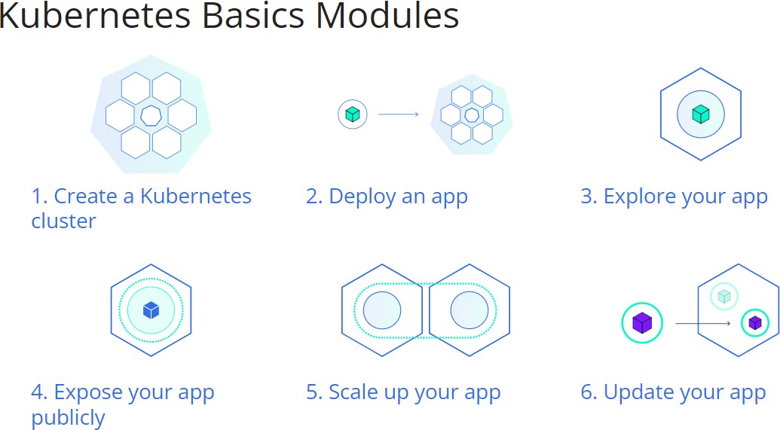

**Procedure:**

1. Explore all 1 to 4 modules
2. 10 kubctl commands on killercoda (online playground)
3. Deploy an app on killercoda (online playground)
4. Explore and Expose an app

**Results: (Result of Steps with screenshots)**

**Module 1:**

Cluster Initiated: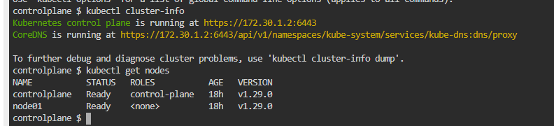

**Module 2:**

Deploying on cluster:  
Nginx deployment:  
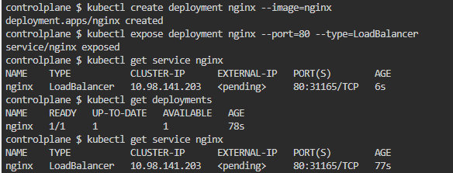

Exposing deployment:

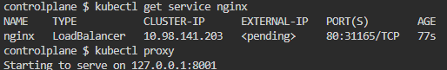

Curling on second tab:

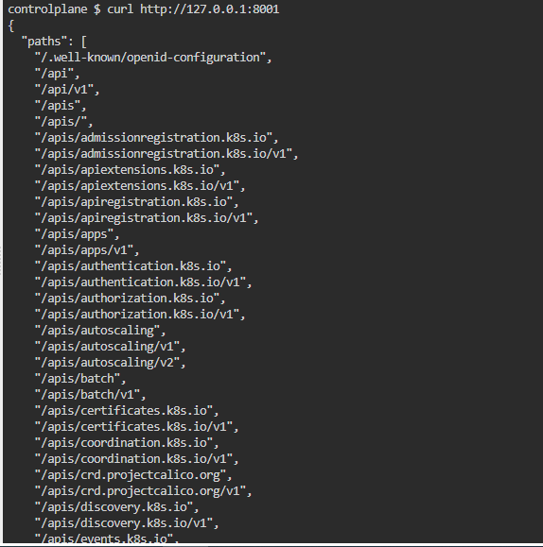

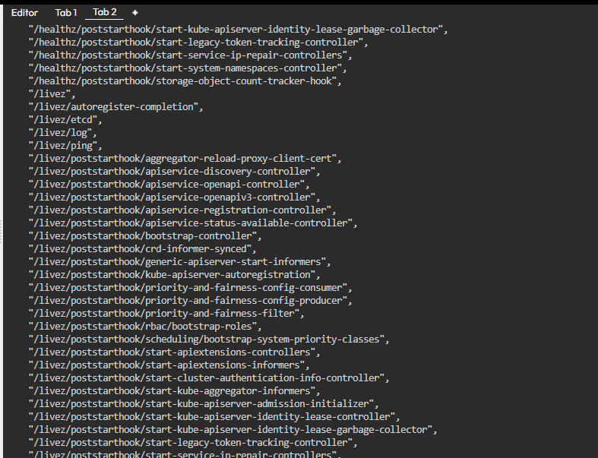

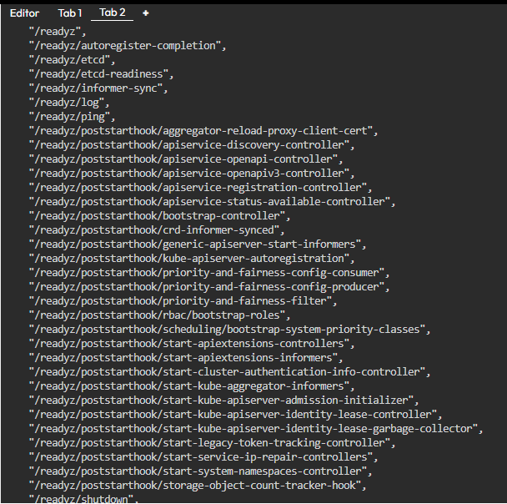

**Module 3:**  
Exploring application:

Get pods:  
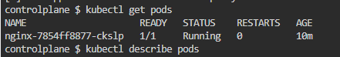

Describe pods:

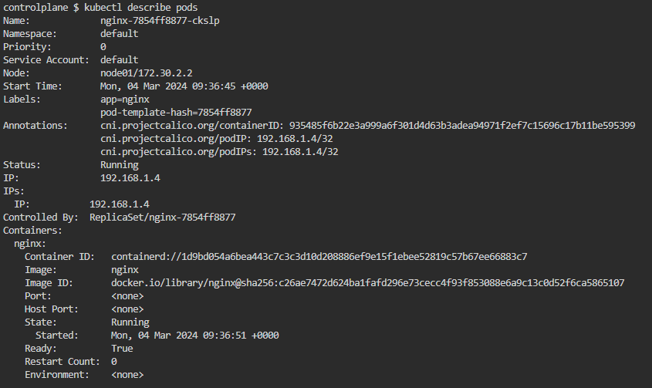

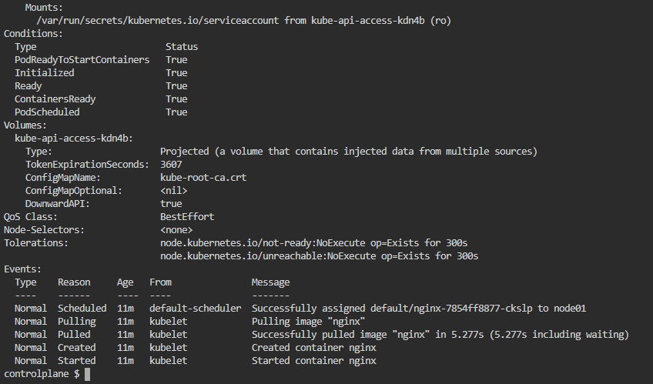

Exposing on proxy:  


Exlporing pods on another tab:  
curl <http://localhost:8001/api/v1/pods>  
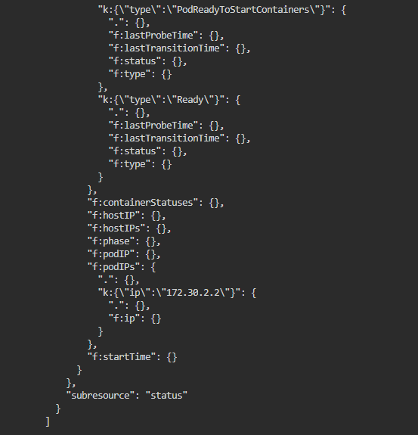

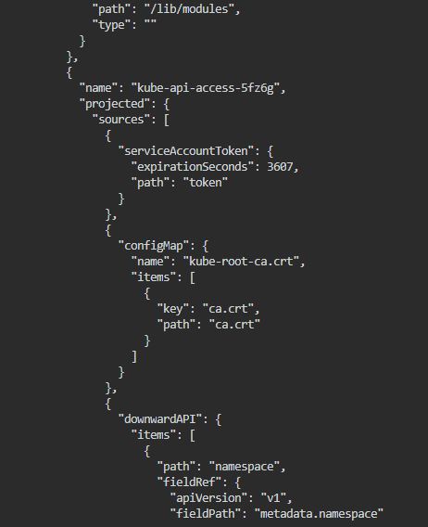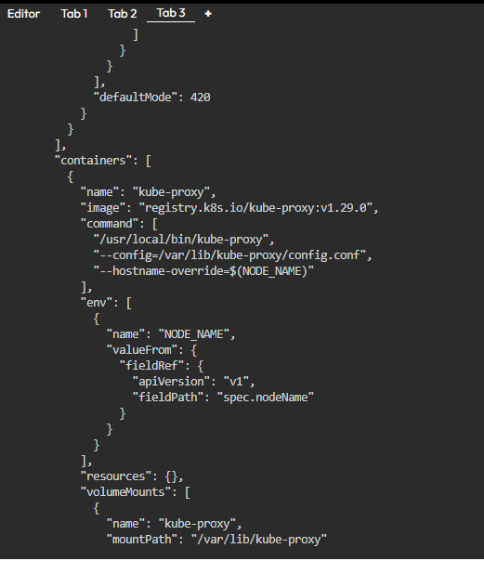

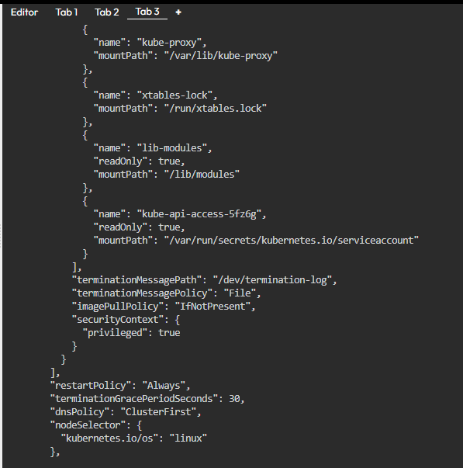

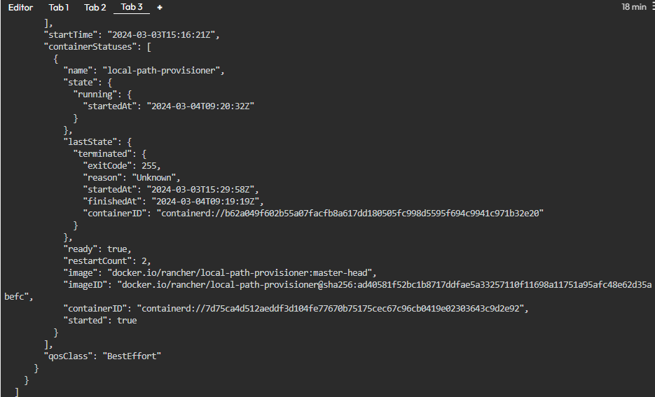

**Questions:**

Q1. Explain micro-services with an example.

Microservices architecture is an approach to software development where a large application is built as a collection of small, independent services, each focusing on a specific business capability. These services are loosely coupled, meaning they can be developed, deployed, and scaled independently. Each microservice typically corresponds to a single function or a small set of related functions within the larger application.

**Outcomes:**

**Conclusion:**

**Grade: AA / AB / BB / BC / CC / CD /DD Signature of faculty in-charge with date**

**References:**

**Websites:**

* <https://kubernetes.io/docs/tutorials/kubernetes-basics/>
* <https://killercoda.com/playgrounds/scenario/kubernetes>